Project Design Phase-II Technology Stack (Architecture & Stack)

|  |  |
| --- | --- |
| Date | 16 October 2022 |
| Team ID | PNT2022TMID42272 |
| Project Name | Smart Waste Management for Metropolitan Cities |
| Maximum Marks | 4 Marks |

# Technical Architecture:

The Deliverable shall include the architectural diagram as below and the information as per the table1 & table 2

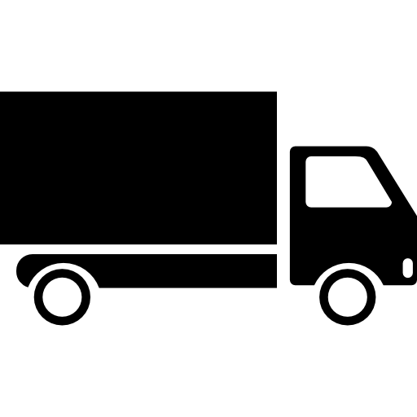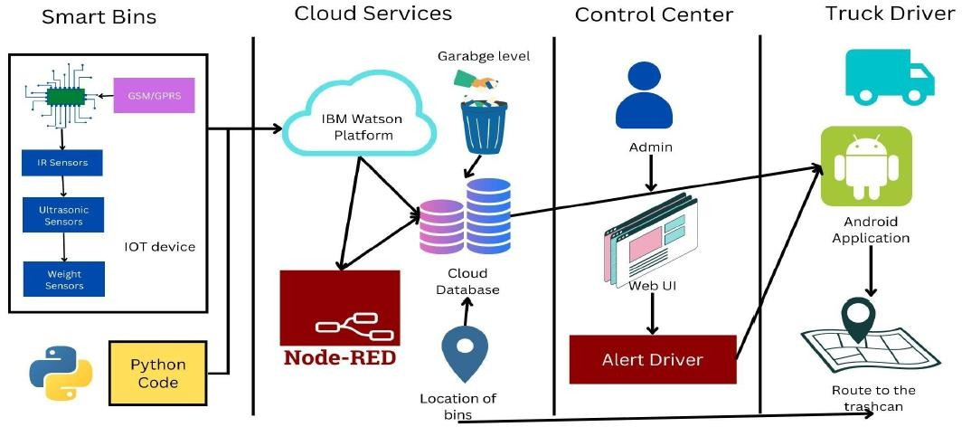

# Table-1 : Components & Technologies:

|  |  |  |  |
| --- | --- | --- | --- |
| **S.No** | **Component** | **Description** | **Technology** |
| 1. | Application | It is the platform for interaction of user with the admin (municipality corporation) | HTML, Python |
| 2. | Ultrasonic Sensor | It measures the distance of top of garbage to the base of it using ultrasonic waves. | a transducer to send and receive ultrasonic pulses |
| 3. | GPS Sensor | They receive the data from the satellites regarding the location of garbage to be collected | GPS satellites |
| 4. | Cloud Database | For the storage of user info, location of garbage bins etc., | IBM DB2, IBM Cloud etc. |
| 5. | Lithium Ion Battery | A lithium-ion (Li-ion) battery is an advanced battery  technology that uses lithium ions as a key component of its electrochemistry. | the positive to the negative electrode |
| 6. | Wifi Module | The ESP8266 WiFi Module is a selfcontained SOC with integrated TCP/IP protocol stack that can give any microcontroller access to your WiFi network. | IEEE 802 protocol |
| 7. | Transport | A vehicle for the collection of bins. | Garbage truck |

**Table-2: Application Characteristics:**

|  |  |  |  |
| --- | --- | --- | --- |
| **S.No** | **Characteristics** | **Description** | **Technology** |
| 1. | Open-Source Frameworks | Template for software development that is designed by a social network of software developers. These frameworks are free for public  use | Python |
| 2. | Security Implementations | provides the technical security policies,  requirements, and implementation details for eliminating the security weaknesses | GSM/GPRS. |
| 3. | Scalable Architecture | scalable architecture supports higher workloads without any fundamental changes to it. | Node Red. |
| 4. | Availability | The quality or state of being available trying to improve the availability of affordable housing. | Cloud, DB. |
| 5. | Performance | The execution of an action | IBM Waston IoT Platform. |